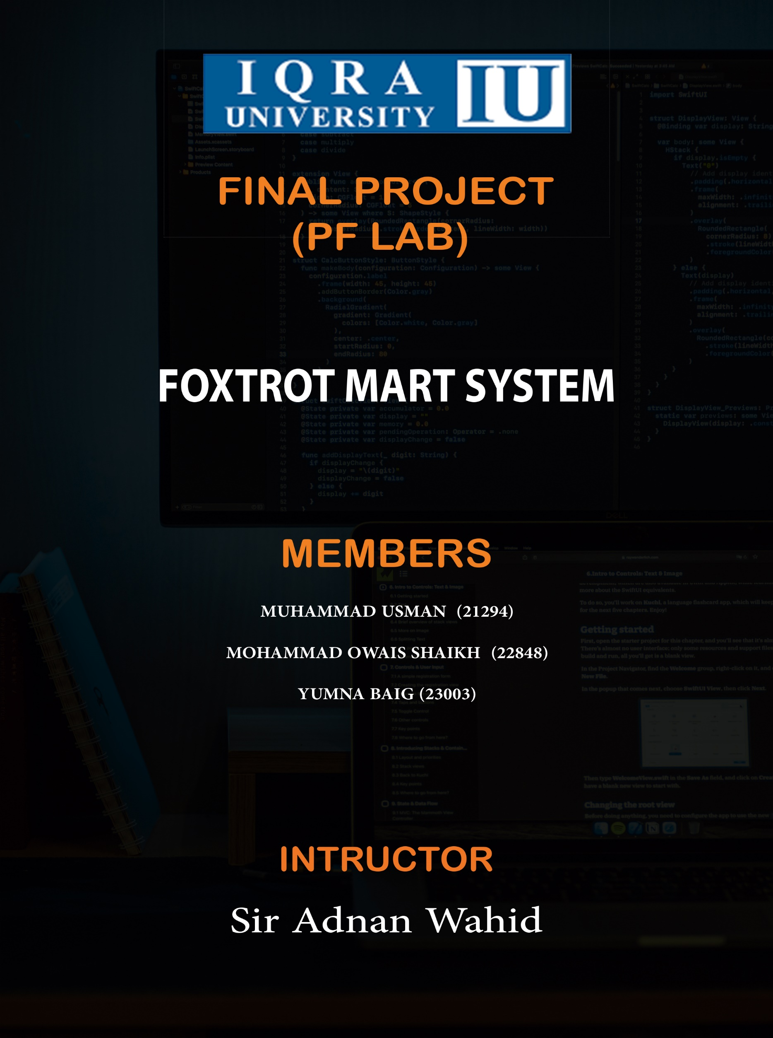

INTRODUCTION OF THE SOUCRE CODE

Using C++ as our programming language, we developed the MART. With the help of the C++ programming language, we may also make a wide range of other programs, including games, calculators, management systems, and more.

DESCRIPTION OF THE SOURCE CODE

This code creates a simple console-based program that simulates a shopping experience at a storecalled "Foxtrot Mart." The program presents the user with options for different types of items topurchase, such as food items or cleaning items. The user can select a category and then select aspecific item from that category. The code then calculates the total cost of the items selected andapplies a discount if the total cost is above a certain amount. The program also allows the user tocontinue shopping after making a purchase.

ALGORITHM

This program goes through the following steps:1. Display welcome message and discount offer2. Show options for different types of items to purchase3. Ask user to select a category4. Show options for specific items within the selected category5. Ask user to select a specific item6. Ask user for the quantity of the selected item7. Add the cost of the selected item to the running total8. Ask user if they would like to continue shopping9. If yes, repeat steps10. If no, calculate the total cost and apply discount if applicable11. Display the final total cost and the amount of discount (if any)

FLOW CHART

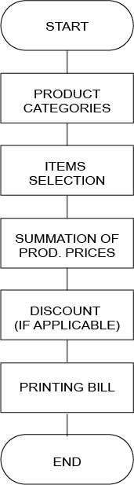

SOURCE CODE

(HEADER FILE CODE)

#include<iostream>

using namespace std;

void foodItems(){

cout << "__________FOOD ITEMS__________";

cout << endl << endl;

cout << "1) Shwarma-----------$8." << endl;

cout << "2) French Fries------$5." << endl;

cout << "3) Zinger Burger-----$20." << endl;

cout << "4) Pizza-------------$30." << endl;

cout << "5) Pizza Fries-------$15." << endl;

cout << "6) Club Sandwich-----$10." << endl;

}

void cleaningItems(){

cout << "__________CLEANING ITEMS__________";

cout << endl << endl;

cout << "1) Teeth brush-----------$8." << endl;

cout << "2) Bottle spray----------$5." << endl;

cout << "3) Dishwasher soap-------$20." << endl;

cout << "4) Sponge----------------$3." << endl;

cout << "5) Shoe polish-----------$15." << endl;

cout << "6) Shoe brush------------$10." << endl;

}

void sportsItems(){

cout << "__________SPORTS ITEMS__________";

cout << endl << endl;

cout << "1) Tennis Racket -$8." << endl;

cout << "2) Football ------$30." << endl;

cout << "3) Cricket Bat ---$60." << endl;

cout << "4) Cricket Ball --$25." << endl;

cout << "5) Golf Ball -----$15." << endl;

cout << "6) Hockey --------$50." << endl;

}

void computerItems(){

cout << "__________COMPUTER ITEMS__________";

cout << endl << endl;

cout << "1) Keyboard-----------$4." << endl;

cout << "2) Mouse------$4." << endl;

cout << "3) Speakers-----$20." << endl;

cout << "4) LED-------------$50." << endl;

cout << "5) Handfree-------$3." << endl;

cout << "6) Mouse Pad-----$2." << endl;

}

void options(){

cout << "1) Food Items" << endl;

cout << "2) Cleaning Items" << endl;

cout << "3) Sports Items" << endl;

cout << "4) Computer Items" << endl;

cout << "5) Exit." << endl << endl;

}

(MAIN CODE)

#include<iostream>

#include "myfirst.h"

using namespace std;

int main()

{

int opt1;

int opt2;

int q;

bool choice;

int sum = 0;

cout << " ___________________________________________ " << endl;

cout << "|___________WELCOME TO FOXTROT MART___________|" << endl << endl;

cout << endl;

cout << "There will be a 10% DISCOUNT On $150 OR more than $150 shopping" << endl << endl;

morebilling:

options();

cout << "Enter the Option: ";

cin >> opt1;

cout << endl << endl;

if (opt1 == 1)

{

foodItems();

cout << "Select option: ";

cin >> opt2;

cout << endl;

if(opt2 == 1){

cout << "Shwarma-----------$8." << endl;

cout << "Quantity: ";

cin >> q;

sum +=8*q;

}

else if(opt2== 2){

cout << "French fries-----------$5." << endl;

cout << "Quantity: ";

cin >> q;

sum += 5*q;

}

else if(opt2== 3){

cout <<"Zinger Burger-----$20." << endl;

cout << "Quantity: ";

cin >> q;

sum +=20*q;

}

else if(opt2== 4){

cout << "Pizza-------------$30." << endl;

cout << "Quantity: ";

cin >> q;

sum +=30*q;

}

else if(opt2== 5){

cout << "Pizza Fries-------$15." << endl;

cout << "Quantity: ";

cin >> q;

sum +=15*q;

}

else if(opt2== 6){

cout << "Club Sandwich-----$10." << endl;

cout << "Quantity: ";

cin >> q;

sum +=10*q;

}

else {

cout << "Invalid selesction" << endl;

}

cout << "Want to buy more? (1/0)" << endl;

cin >> choice;

cout << endl;

if (choice == 1){

goto morebilling;

}

}

else if (opt1 == 2)

{

cleaningItems();

cout << "Select option: ";

cin >> opt2;

cout << endl;

if(opt2 == 1){

cout << "Teeth brush-----------$8." << endl;

cout << "Quantity: ";

cin >> q;

sum +=8*q;

}

else if(opt2== 2){

cout << "Bottle spray----------$5." << endl;

cout << "Quantity: ";

cin >> q;

sum +=5*q;

}

else if(opt2== 3){

cout << "Dishwasher soap-------$20." << endl;

cout << "Quantity: ";

cin >> q;

sum +=20*q;

}

else if(opt2== 4){

cout << "Sponge----------------$3." << endl;

cout << "Quantity: ";

cin >> q;

sum +=3*q;

}

else if(opt2== 5){

cout << "Shoe polish-----------$15." << endl;

cout << "Quantity: ";

cin >> q;

sum +=15*q;

}

else if(opt2== 6){

cout << "Shoe Brush-----------$10." << endl;

cout << "Quantity: ";

cin >> q;

sum +=10*q;

}

else {

cout << "Invalid selesction" << endl;

}

cout << "Want to buy more? (1/0)" << endl;

cin >> choice;

cout << endl;

if (choice == 1){

goto morebilling;

}

}

else if (opt1 == 3)

{

sportsItems();

cout << "Select option: ";

cin >> opt2;

cout << endl;

if(opt2 == 1){

cout << "Tennis Racket-----------$8." << endl;

cout << "Quantity: ";

cin >> q;

sum +=8*q;

}

else if(opt2== 2){

cout << "Football----------$30." << endl;

cout << "Quantity: ";

cin >> q;

sum +=30*q;

}

else if(opt2== 3){

cout << "Cricket Bat-------$60." << endl;

cout << "Quantity: ";

cin >> q;

sum +=60*q;

}

else if(opt2== 4){

cout << "Cricket Ball-------------$25." << endl;

cout << "Quantity: ";

cin >> q;

sum +=25*q;

}

else if(opt2== 5){

cout << "Golf Ball----------------$15." << endl;

cout << "Quantity: ";

cin >> q;

sum +=15*q;

}

else if(opt2== 6){

cout << "Hockey-----------$50." << endl;

cout << "Quantity: ";

cin >> q;

sum +=50*q;

}

else {

cout << "Invalid selesction" << endl;

}

cout << "Want to buy more? (1/0)" << endl;

cin >> choice;

cout << endl;

if (choice == 1){

goto morebilling;

}

}

else if (opt1 == 4)

{

computerItems();

cout << "Select option: ";

cin >> opt2;

cout << endl;

if(opt2 == 1){

cout << "Keyboard-----------$4." << endl;

cout << "Quantity: ";

cin >> q;

sum +=4*q;

}

else if(opt2== 2){

cout << "Mouse----------$4." << endl;

cout << "Quantity: ";

cin >> q;

sum +=4*q;

}

else if(opt2== 3){

cout << "Speakers-------$20." << endl;

cout << "Quantity: ";

cin >> q;

sum +=20*q;

}

else if(opt2== 4){

cout << "LED-------------$50." << endl;

cout << "Quantity: ";

cin >> q;

sum +=50*q;

}

else if(opt2== 5){

cout << "Handfree----------------$3." << endl;

cout << "Quantity: ";

cin >> q;

sum +=3*q;

}

else if(opt2== 6){

cout << "MousePad-----------$2." << endl;

cout << "Quantity: ";

cin >> q;

sum +=2*q;

}

else {

cout << "Invalid selesction" << endl;

}

cout << "Want to buy more? (1/0)" << endl;

cin >> choice;

cout << endl;

if (choice == 1){

goto morebilling;

}

}

else if(opt1 == 5){

cout << "You are exited" << endl;

}

else{

cout << "Invalid" << endl;

}

cout << "Your bill is $" << sum << endl;

cout << "----------------" << endl;

if (sum>=150){

sum = sum- (10*sum/100);

cout << "After discount, The bill is $" << sum << endl;

cout << "----------------" << endl;

}

cout << endl << endl;

cout << "----------------" << endl;

cout <<"Thanks for coming!" << endl;

cout << "----------------" << endl;

return 0;

}